**LEARN KARATE**

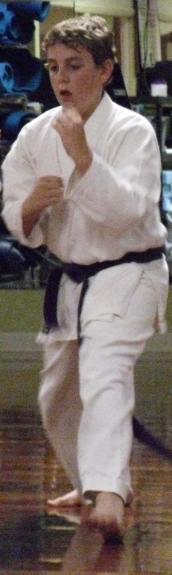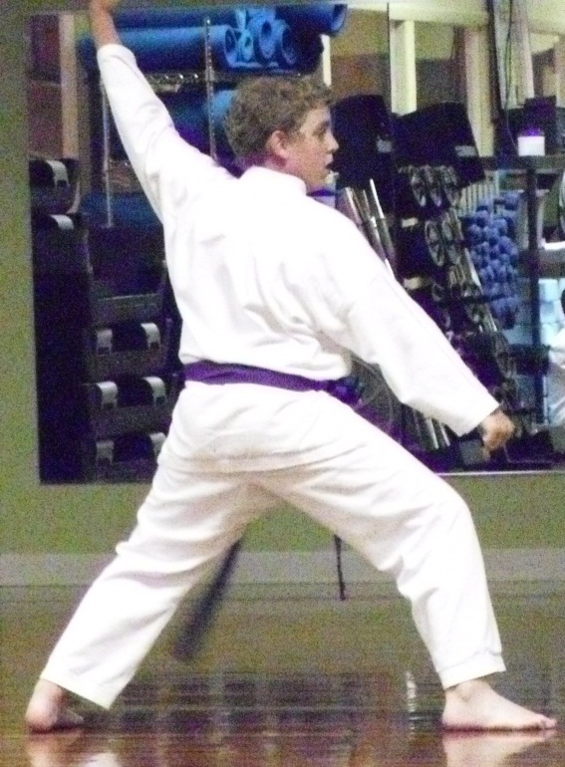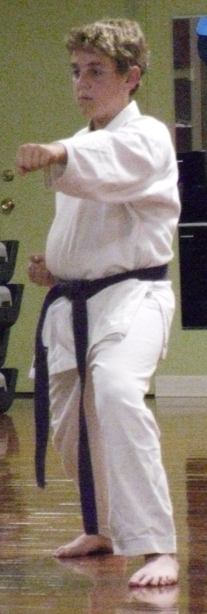

Ruben’s Karate Academy offers beginning and advanced classes for youth *and* adults. Classes focus on technique and stance, kata, and sparring.

* Increase muscular and aerobic fitness
* Improve strength and mental alertness
* Develop self-confidence, discipline, and sportsmanship

**Sign Up Today! Call 555-3454.**